Analysing Customer Satisfaction Trends of Airlines by Using Hadoop MapReduce Techniques

Nikhil Kamath
MSc. In Data Analytics
National College of Ireland

Abstract— The airline industry is one where events are very fast paced and continuous. To every airline, customer satisfaction and profit are the two key factors for their success. To cater to the needs of the ever increasing population, airlines continuously acquire feedback to improve on their services and make sure they are top notch so that their customers are satisfied and happy. In this project, what is being attempted here is to analyze customer reviews of airlines through using the Hadoop MapReduce technology. Pig and Hive would be used to process the data and then the results would then be visualized to give a detailed aspect on how customer satisfaction can play a vital role in any airline’s success. A total of six business cases were formulated with respect to different areas of concentration of passenger satisfaction and they were analyzed with the help of the visualizations.
Keywords— airline, customer satisfaction, Hadoop MapReduce, Pig, Hive, visualized.

INTRODUCTION
In today’s era, travel by air has increased more than ever before. The airline industry is one which never pauses for any break and is one of the most developed ones as the years have passed. This has been mainly due to the sharp and significant increase in the population all across the world, and frequent air travel has been one of the top activities of many people.
The airline industry has become a very prominent area of research in the past few years. One of the primary areas where airlines perform continuous research is the effect of customer satisfaction, which plays a very key role in determining the success of any airline. Airlines usually spend a large amount of money on activities that help them achieve ultimate customer satisfaction. Examples of areas where airlines usually invest in include in-flight services such as entertainment, food and staff courtesy, making seats comfortable to sit in in their fleet and optimizing ground services for passengers.
Through the course of this project, what would be analyzed is how different areas of expenditure of airlines would affect the customer satisfaction. The question that would be attempted to be answered through this project would be “Which airlines fare the best in different areas of customer satisfaction?” The data collected for this is in the form of customer reviews.
The remaining sections of this project report are distributed as follows. Section II details on some related research work that has been performed on the stated research question. Section III explains the methodology and implementation of this project in detail. Section IV shows the results of this implementation, and Section V concludes the report and may input some possible future work that can be performed.

LITERATURE REVIEW
Airline travel has been an eye-catching area of interest to many researchers worldwide, and quite a bit of experimentation has been done in this industry. A few noted works in this field are described below.
Milan Bhatt [1] in his article talked about how the power of social can significantly impact the image of any airline. He elaborated this by showing a tweet of a customer not happy with an airline’s customer service and even though the airline had resolved the problem, by that time the post had become viral, and that had damaged the airline’s brand name. He also mentioned some prospective solutions toward solving the real problem regarding this [1].
[2] elaborated on the effect of wait times on an airline’s customer satisfaction. Wait times are a significant factor considered when it comes to customer patience and satisfaction. They had analysed trends based on certain factors that are probable effects on the customer wait time. They then gathered data and portrayed some graphical aspects on the trends they analysed [2].

METHODOLOGY AND IMPLEMENTATION
The implementation of this project will be as follows. The data would be first extracted from the source, preprocessed and then loaded onto MySQL and subsequently onto HDFS. After that, the Hadoop MapReduce Technology would be performed on the data to process it through the Apache Pig and Hive technologies.
After processing the data through Pig and Hive, the resulting data would then be stored back into Hadoop HDFS and then extracted as a CSV file to be visualized in R and Tableau. The same is illustrated in the form of a process flow diagram. These processes are explained in details below.
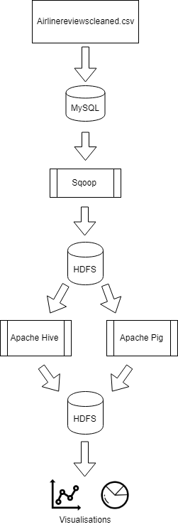

- Data Processing Flow Diagram

Data Gathering and Preprocessing

For this project, the dataset used was a .CSV file which was directly extracted from Github. The URL for the main dataset is ‘https://github.com/quankiquanki/skytrax-reviews-dataset’. This Github site was a part of the suggested public dataset sites of another Github page, having the URL ‘https://github.com/awesomedata/awesome-public-datasets’. The raw dataset contains 41396 rows, with 20 columns. This dataset contains information of travelers reviewing their travel experiences with airlines. This data has been scraped and collected from the Skytrax website. Skytrax is a recognized airline quality assurance authority worldwide, which helps in enhancing the customer satisfaction for airlines and airports [3].
The reason behind selecting this dataset is as this contains various important factors that airlines pay important attention to especially when it comes to satisfying customers with their services. In addition, analysis of this data would yield great results due to its quantity. This would also attempt to a great extent to provide a good enough answer to the research question.
The attributes of this dataset include various factors or criteria that passengers consider while traveling with airlines. To make the data suitable enough for processing in the big data technologies, the dataset had to be cleaned. This was done entirely using ‘R’, using the ‘R Studio’ tool. The code for the data cleaning process is attached with the project submission materials. During the process of cleaning, firstly the unwanted columns of the dataset were erased. These included 7 columns which were not needed for the analysis. The attributes after cleaning the dataset include id, airline-name, date, type_traveller, cabin_flown, overall_rating, seat_comfort_rating, cabin_staff_rating, food_beverages_rating, inflight_entertainment_rating, ground_service_rating, wifi_connectivity_rating, value_money_rating, and recommended.
Out of the remaining data, a lot of the numeric columns had quite a few missing values, i.e. having NA values. To fix this issue, by using the R tool, what was done was that the missing values were ‘imputed’ with the ‘mean’ or ‘average’ value for that particular column. The non-numeric columns such as type_traveller and cabin_flown too had a lot of missing values. Hence, to eliminate this, an assumption was made that the missing values for ‘type_traveler’ would be replaced by ‘Solo Leisure’, and the missing values for ‘cabin_flown’ would be replaced by ‘Economy’.
After the data was cleaned fully as per the above procedures, the data is now ready to be input for processing.

Data Processing

As explained above, the first step that was performed prior to processing the data was the preprocessing, i.e. preparation, exploration and cleaning of the data. Once that was completed, the data was then loaded onto the MySQL database. For the same, a database named ‘PDA’ was created, followed by a table which was created in the MySQL database. The project was performed on a virtual machine (using Oracle VM VirtualBox) on an Ubuntu Linux operating system. The Ubuntu version was 16.04 and had specifications of: 50 gigabytes (GB) hard disk and 4 GB allocated Random Access Memory (RAM). The Hadoop ecosyatem was installed along with Sqoop, Pig, Hive, and MySQL.

To enhance the file sharing between the Windows machine and the Ubuntu virtual machine, a ‘shared folder’ was created. The pre-processed .CSV file from the data source was input into the virtual machine through the shared folder. Next, this file was input into MySQL using the following command through the Linux shell: ‘load data local infile '/home/hduser/Desktop/PDA_project/airlinereviewscleaned.csv' into table airlinereviews fields terminated by ',' lines terminated by '\n’; This command allows the csv file to be copied from the local system into the MySQL table created.

After that, the data was input into the Hadoop Distributed File System (HDFS). This process was done through a technology developed by Apache, called ‘Sqoop’. The transfer was done by inputting the following command through the linux shell in the sqoop home directory: ‘sqoop import --connect jdbc:mysql://127.0.0.1/PDA --username root --password password --table airlinereviews --target-dir /sqoop/airlinereviews’. The main data processing was performed using the Apache Pig and Apache Hive tools. Both these tools run on the Hadoop MapReduce framework. The source code for the Pig and Hive data processing is attached with the project submission materials.

For the analysis of the data, a total of six business cases were formulated and accordingly the relevant queries were formed in Pig and Hive. The queries were equally written and performed on both tools, i.e. three queries in Pig and three in Hive. The queries and their output files along with the generated csv files are included in the project submission materials files. Once in HDFS, the data was just extracted and converted into a text file, and subsequently a csv file after exporting it to the local file system. A separate csv file was generated for each query individually. For Pig, the output was stored in a file named ‘part-r00000’, and for Hive, the output was stored in a file named ‘00000’ in HDFS.

Following the extraction and conversion of data into csv format, the analysis of the generated data would be illustrated and explained in the following section. The visualizations were generated through the ‘R Studio’ and ‘Tableau’ tools. All the queries were written to analyse different aspects of customer satisfaction, which areas of airline services do airlines prosper in, and which areas are airlines not too good and need improvement in. In addition, a comparison is done between airlines to see which airlines excel in which areas of service to passengers. A brief overview of the technologies used in the project are described below.

Technologies Overview
The technologies utilized here for this project to process the data are: MySQL, Apache Sqoop, Apache Pig, Apache Hive, Hadoop HDFS, and Hadoop MapReduce.

- MySQL

MySQL is another alternative to the traditional SQL databases. MySQL also operates as a relational database management system [4]. MySQL was used in this project as it has the capacity to handle relatively large amounts of data, but slightly smaller than big data, in which case a NoSQL database would be used.

- Apache Sqoop

Sqoop is a tool created by Apache. Sqoop is used mainly as a medium of transfer of data between databases. Sqoop handles the transfer of data between Hadoop HDFS and relational databases. The Hadoop MapReduce methodology is utilized over here to facilitate the transfer process [5].

- Hadoop HDFS

The Apache Hadoop Distributed File System (HDFS), as the name states, is a file system used to store large amounts of data. This facility in HDFS makes it a more convenient storage system when dealing with large amounts of data. HDFS also is designed in a manner to make it function on cheaper hardware, and in addition to this, fault tolerance is significantly facilitated in HDFS [6].

- Hadoop MapReduce

The Hadoop MapReduce is a framework that is utilized to enhance smooth processing of large amounts of data in a proper manner. MapReduce is normally used at a large scale, usually in environments containing a very large number of nodes and clusters [7]. MapReduce processes the data in the form of jobs, having two main segments.

The first segment is the map segment which performs a split up of the blocks of data and processes the split up blocks. The map job then inputs the data to the reduce jobs which process the data, and then stores it in a file system. The mapper and reducer jobs have a format of keys and values [7].

- Apache Pig

The Apache Pig platform is used mainly for detailed analysis of large amounts of data. Pig uses queries in the form of scripts to process and analyse the data. The scripting language used over here is ‘Pig Latin’ [8]. This language enables users to perform data processing through functions such as grouping, merging or filtering of data [8]. Pig contains inbuilt MapReduce scripts that automatically execute the jobs through Hadoop once the Pig script is run [8].

- Apache Hive

The Apache Hive is a software which enables users to store large amounts of data. One of the most positive features of Hive is that the syntax of the queries run to retrieve data is the same as those used in traditional SQL databases [9]. Hive runs on top of Hadoop and has the ability as well, similar to Pig, to run MapReduce jobs to query and retrieve data stored in the Hive database. Hive has the feature as well to automatically transfer the queried data onto HDFS or other NoSQL database systems such as Apache HBase [9].

RESULTS

The data was processed through the six queries in Pig and Hive, and the corresponding results were stored in HDFS. The results shown below are an analysis of the processed data and six business cases formulated through that data. Clearer graphs of all business cases are attached with the project submission materials in case the ones in this report are unclear.

Business Case 1

The first business case that would be analysed is: ‘Which airline has the highest overall rating? Through this, what would be analysed here is a comparison between airlines with regards to the overall customer rating given to those airlines. A graphical output illustrating this is shown below.
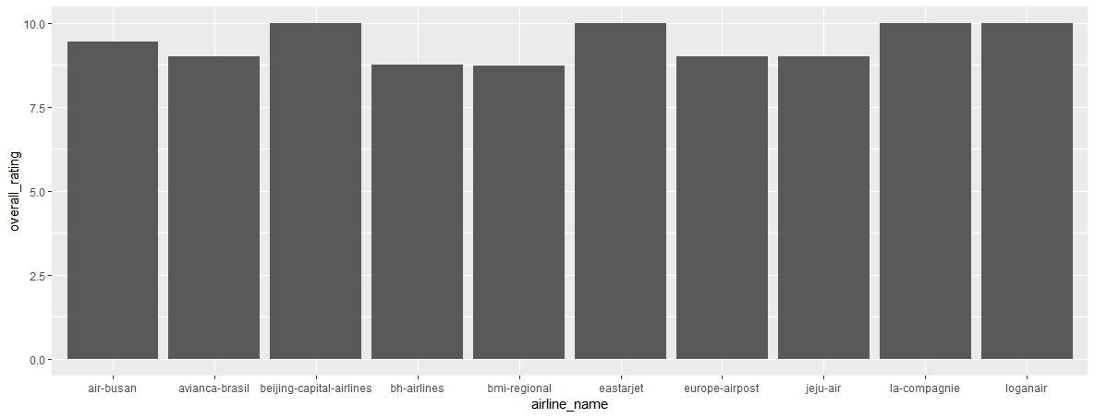
Fig. 2. A comparison of airlines having highest overall rating
For the representation of this business case, as the number of airlines is high and the top airlines having best overall rating is being compared, the data was sorted in descending order as per overall rating. From that, the top ten results were chosen for the visualization. After that, the above plot was generated in the R Studio tool. It can be noticed by the graph that four airlines, Beijing-capital airlines, eastarjet, la compagnie and loganair are having the highest overall rating of 10, which is the highest value on the scale. The remaining airlines shown are having the overall rating range between 7 and 10, which also are good ratings. This business case was performed to get an idea of the analysis of which airlines are performing well in terms of customer satisfaction.

Business Case 2
The second business case being analysed is with regards to value for money. The query being posed here is ‘Which airline has the highest value for money?' For the representation of this business case also, the results have been sorted in descending order due to the large number of airlines, also in addition the top 10 airlines would be chosen here as well for the same reason. A graph showing the resulting analysis is shown below.
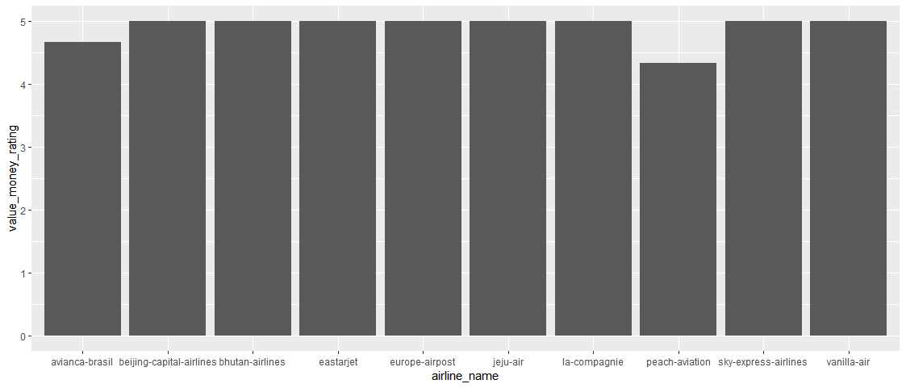
Fig. 3. A comparison of airlines having highest value for money
From the results, it can be inferred that, among the top 10 airlines having the highest value for money, apart from two airlines, peach aviation and avianca brasil, the remaining airlines have the highest rating for the value for money, meaning that the satisfaction of these airlines is very high due to their effective pricing strategy that they have put in place. Money invested is a prime concern for everyone, and is considered one of the most primary factors towards making any decision, in this context air travel. In addition to money, what matters even more is what services you get for that money.
Hence, using this analysis, airlines having lower ratings with respect to value for money can explore their options and find out reasons behind passengers not being satisfied with what they are paying for and can improve on their marketing and pricing strategy to improve the ratings.

Business Case 3

The third business case aims to figure out airline customer satisfaction among families. The query being asked over here is ‘Which airline is most popular among families?. As re-iterated previously, the top 10 rated airlines among families would be considered over here. The graph of this analysis is shown below.

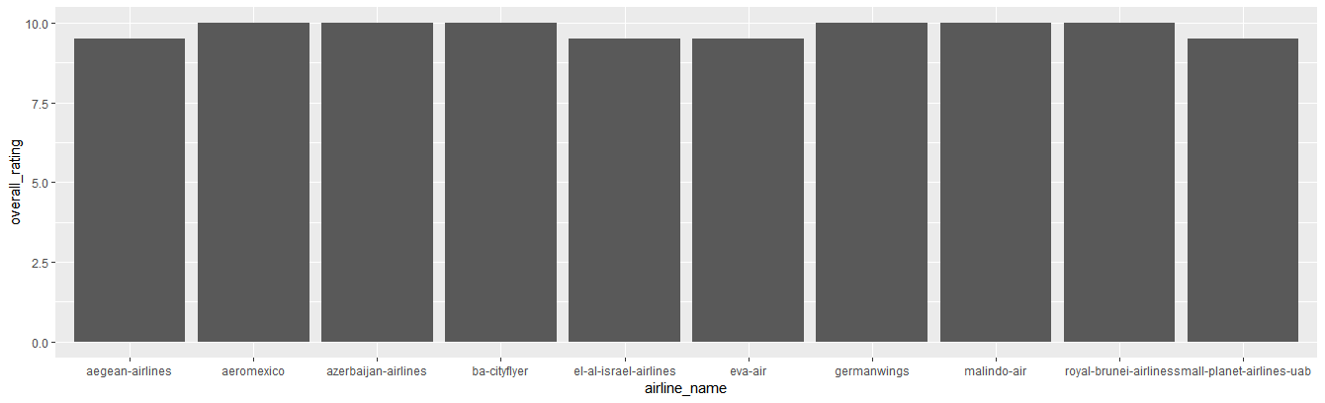
Fig. 4. A comparison of airlines having highest overall rating among families
Inferring from the above graph, it can be seen that six out of the top 10 airlines have the highest popularity among families, namely aeromexico, azerbaijan airlines, ba-cityflyer, germanwings, malindo air, and royal brunei airlines. The reason behind these airlines being popular among families may be due to the discounts or promotions they offer to families, which again redirects to the marketing strategies that airlines employ to make their clients satisfied.

Business Case 4
The fourth business case that will be analysed is with regards to the recommendation of the airline between customers. Recommendation too plays an extremely important role in customer satisfaction. It shows that passengers are happy with the airline’s services and that they would most likely fly again with that airline, as well as recommend it to others.
The below analysis shows a graph of the top ten airlines and how frequently they have been recommended to other passengers.
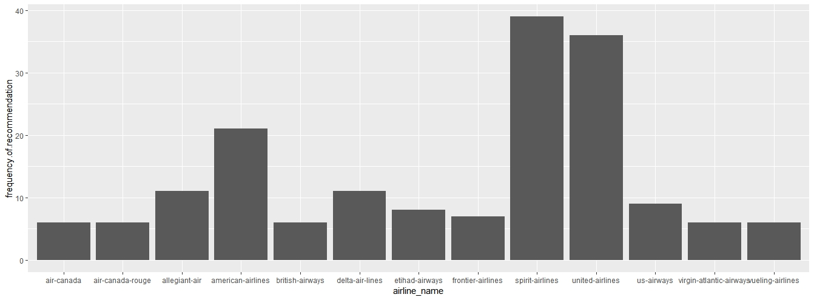
Fig. 5. A comparison of the frequency of recommendation of airlines
From the graph, it can be inferred that from the top ten most recommended airlines, two airlines, namely spirit airlines and united airlines, have been most frequently recommended by travellers to others. After those, it is American airlines which is frequently recommended to travellers. Frequent recommendation means that customers seem more satisfied with the airline’s services, which makes it better for the airline to serve frequent fliers better and better improve their services.
Airlines that have a low frequency of recommendation can look into factors where they lack by observing their competitors and areas they are excelling in, and better improve themselves in those areas to fly passengers better and get themselves recommended more frequently.

Business Case 5

The fifth business case deals with regards to the services of airline’s economy class in terms of seat comfort and food and beverages. These two factors also play a very important role in deciding whether a passenger should fly an airline or not. It is also often noticed that airlines put in a good amount of expenditure in seating and food to ensure that passengers travel with the least stress possible and disembark from the aircraft at the destination with a pleasant flying experience.

The below graphs illustrate airlines which have been rated highly by passengers on seat comfort and food and beverages.

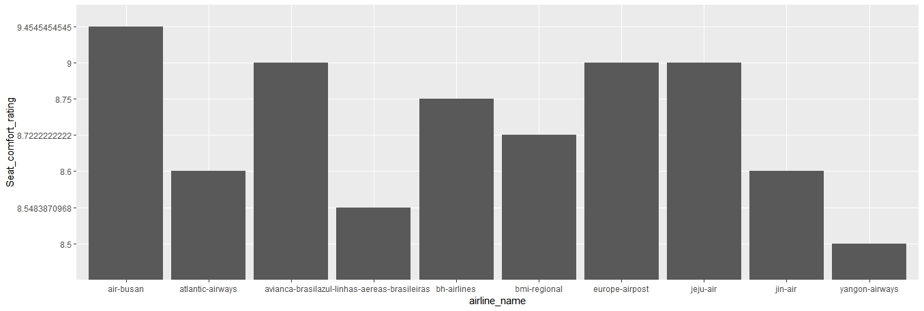
Fig. 6. A comparison of the seat comfort rating of airlines
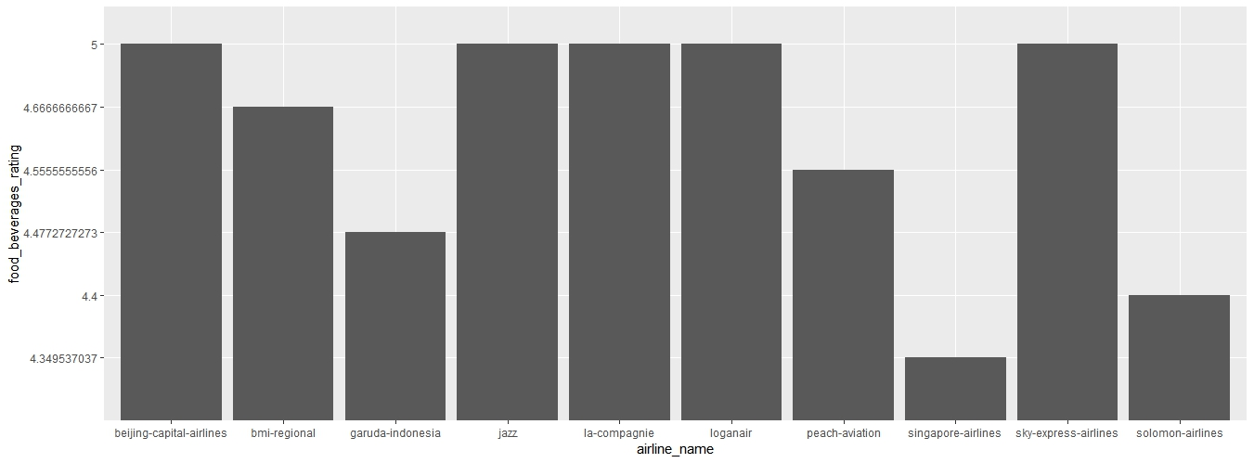
Fig. 7. A comparison of the food and beverages rating of airlines
From the first graph, it can be observed that air busan and avianca brasil rated highly on the seat comfort, while the other top airlines were rated a bit lower than the top ones, in the range of between 8 and 9 on the scale.
The second graph shows the top rated airlines with respect to foo and beverages served on board the aircraft in flight. Out of the top 10 rated airlines on the graph, 5 of them have been given the topmost ranking on the scale, namely beijing capital airlines, jazz, la compagnie, loganair, sky express airlines, while the other 5 were ranged a little lower than the top ones. This shows that these airlines have maintained their food quality and also their seats are comfortable as well.
Seat comfort is a very essential requirement when it comes to passenger travel smoothness as that determines the post travel jet lag and tiredness, in other words, if a passenger does not travel in a comfortable seat, he/she is more likely to develop more jet lag after travel, and more likely not to recommend the airline to another person or maybe not fly again.
Food and beverages too determine one’s decision to fly the airline again as here a passenger’s health would be involved. In case any issues occur due to food quality to any passenger, this may hurt the airline’s reputation as well as customer satisfaction, and frequent fliers and recommendations would decrease.

Business Case 6
The sixth and final business case that would be analysed relates to establishing a comparison of which airlines have a very good quality economy class overall. The factors being taken into consideration here are inflight entertainment and wifi connectivity. Internet has become the need of the hour in today’s world, and individuals’ mindsets have also the thought that there is no world without social media and the internet.
This is one of the major reasons why airlines do invest in improving their inflight connection services as well. Similarly, for long haul flights, passengers need to be kept entertained. Here is where the inflight entertainment will need to be kept as top notch as possible in order to keep customers satisfied with entertainment they prefer. The below graphs show the airlines that excel in providing good inflight entertainment and wifi connectivity.
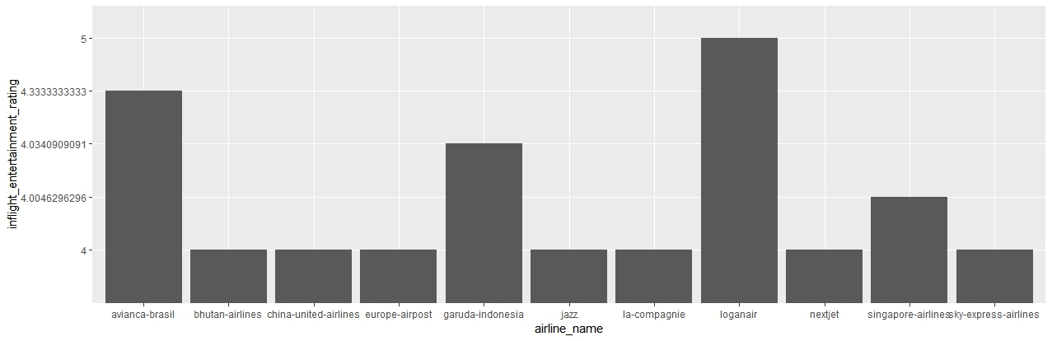
Fig. 8. A comparison of the inflight entertainment rating of airlines
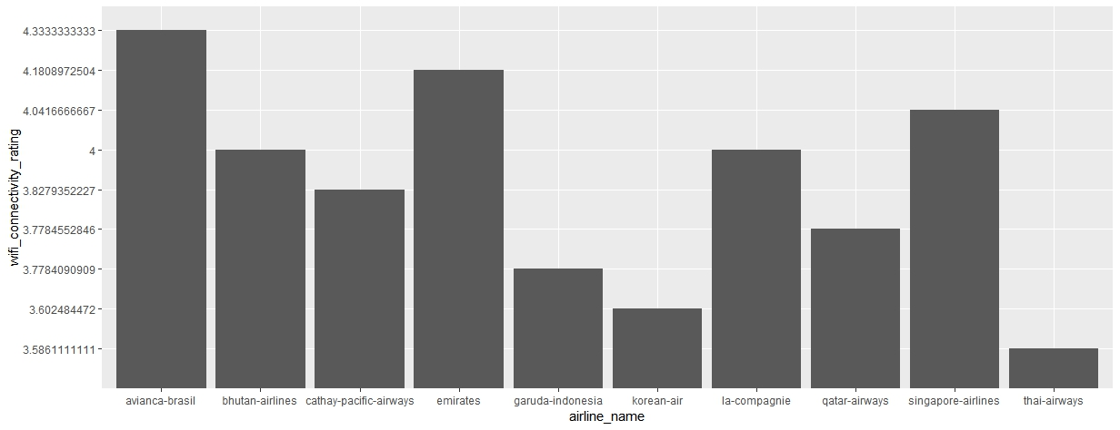
Fig. 9. A comparison of the wifi connectivity rating of airlines
From the first graph above (Fig.8), it can be inferred that loganair had the highest inflight entertainment ranking, followed by avianca brasil and garuda indonesia. From these results, it can also be seen that inflight entertainment is an area that needs more research and development as well as more investment in order to achieve good satisfaction ratings for the same.
From the second graph (Fig. 9) it can be seen that avianca brasil had the highest wifi connectivity rating inflight, followed by emirates and singapore airlines. Again, wifi connectivity, being the primary source of connection between a person and the social world, is an area which needs investment in to get the best satisfaction from passengers as that is what they would ideally look for when they are inflight.

CONCLUSION AND FUTURE WORK
Through this project, a detailed analysis was made of several different concentration areas with regards to customer satisfaction. A comparison was made between different airlines as to which ones excel in each area and also based on different parameters.
In addition, it can be understood through this project that processing big data can be made possible through the Hadoop MapReduce environment, which is cost-friendly and a reliable methodology.
Passenger satisfaction is vital for any airline to succeed. Exploration can be done on other aspects of the industry apart from airline services such as airport services (lounge, procedure smoothness…) and once of the most important aspects possibly, which is reducing flight delays.

REFERENCES

- M. Bhatt, “Getting to Know Your Digital-Age Customers: An Airline Industry Case Study,” Business Intelligence Journal, vol. 21, no. 3, pp. 48-54., Sept 2016.
- H. B. Sankaranarayanan, G. Agarwal and V. Rathod, "An exploratory data analysis of airport wait times using big data visualisation techniques," in 2016 International Conference on Computation System and Information Technology for Sustainable Solutions (CSITSS), Bangalore, 2016, pp. 324-329.
- Skytrax website [Online]. Available: http://www.airlinequality.com/ [Accessed On : 10th August,2018]
- MySQL [Online]. Available: https://en.wikipedia.org/wiki/MySQL [Accessed On: 10th August, 2018]
- Sqoop User Guide [Online]. Available: http://sqoop.apache.org/docs/1.4.7/SqoopUserGuide.html#_introduction [Accessed on: 10th August, 2018].
- HDFS Architecture Guide [Online]. Available: https://hadoop.apache.org/docs/r1.2.1/hdfs_design [Accessed On: 10th August, 2018]
- MapReduce Tutorial [Online]. Available: https://hadoop.apache.org/docs/r1.2.1/mapred_tutorial.html [Accessed On: 10th August, 2018].
- Apache Pig Wiki [Online]. Available: https://cwiki.apache.org/confluence/display/PIG/ [Accessed On: 10th August, 2018].
- Apache Hive Wiki [Online]. Available: https://cwiki.apache.org/confluence/display/Hive/Home [Accessed On: 10th August, 2018]

